**Guided Capstone Project Report**

To determine the optimal course of action for Big Mountain Resort, the comparison between the current ticket price and the modeled price, and the outcomes of the four potential scenarios have been evaluated. The current ticket price for Big Mountain Resort is $81, which is the highest in Montana, as shown in the plot below.

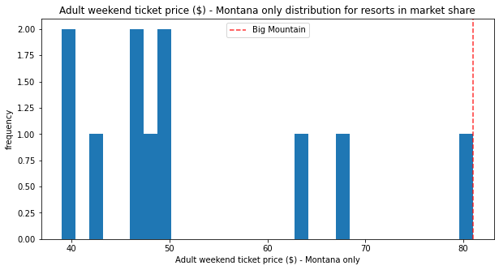

The modeled price inferred from the analysis on the ski resort was $95.87, even higher than the current price. The significant gap between the current and the modeled ticket price for Big Mountain Resort appears to be a strong indicator for supporting a higher price for its ticket price, even with the expected mean absolute error of $10.39. This could also alarm the business leaders because any significant change could be perceived as a potential risk.

Our model has been subsequently utilized to evaluate the four different possibilities, shortlisted by the business, to determine the optimal course of action. The four different possibilities are the following:

1. Permanently closing down up to 10 of the least used runs, which does not impact any other statistics.

2. Increasing the vertical drop by adding a run to a point 150 feet lower down at the expense of an additional chair lift installation, but without any additional snowmaking coverage.

3. Same as number 2, but with the additional 2 acres of snowmaking coverage.

4. Increasing the longest run by 0.2 mile to achieve 3.5 miles length, requiring additional snowmaking coverage of 4 acres.

The assessment and evaluation began with the first scenario by examining the changes in the ticket price support and the revenue in response to the closure of runs using the plots drawn below.

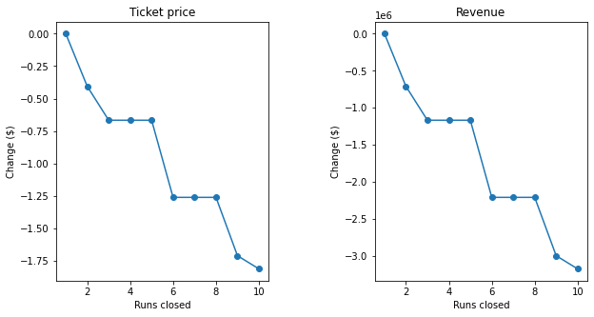

Closing down one run evidently does not result in any noticeable change in the ticket price or the revenue, while subsequent closures reduce the ticket price and the revenue. It is also worth noting that there is no change in the ticket price and the revenue for the interval of closures between third and fifth runs. The ticket price and the revenue drop drastically with the closure of the sixth run. The second scenario increases the support for the ticket price by $1.99, which could mount up to $3474638 over the season. The third scenario was exactly the same as the second scenario, implying that such a small increase in the snowmaking area is insignificant. The fourth scenario did not lead to any changes. This result does not come as a surprise, considering longest run was among the least important features from the random forest model. Our evaluation suggests the second scenario is the most preferred course of action for the business. However, the evaluation remains incomplete without taking the operating cost (e.g. chair lift, snowmaking machine, etc.) into account. Under the current circumstance, without additional information on the operating cost, the recommended course of action would be to proceed with the second scenario along with the ticket price of $82.99, and test whether the closure of one run does not impact the ticket price as the model suggests.